**Racial Identity in a Changing World:**

**The Impacts of Environmental Degradation on Linked Fate**

**Abstract:**

Environmental degradation is an inherently marginalizing experience. A growing body of evidence shows that people of color are more likely to live in areas that experience environmental degradation, are less likely to receive help with remediation and natural disaster relief, and what help they do receive is often condemned rhetorically by politicians and media. Despite a large body of literature denoting the importance of political identity on climate politics, little research examines the causal arrow in the opposite direction. I argue that the experience of local environmental degradation can impact the salience of group positionality in the larger political environment. That environmental degradation and other factors related to climate change are disproportionately felt by the marginalized is not a secret. Just as feelings of alienation due to immigration status make it easier for an individual to feel that their fate is intertwined with that of others in their racial or ethnic group, so too should situations such as pollution, lack of access to clean water, and poorer health outcomes when these events impact groups along racial and ethnic lines. Through use of a novel measure of environmental degradation (proximity to EPA Superfund National Priority List sites), this study investigates degradation impacts on racialized group dynamics in the United States.

**Rose Benton**

**Doctoral Student**

**University of North Texas**

**Dept of Political Science**

It is imperative that political science reaches a more thorough understanding of the impact that humans have had on the global environment and the inevitable impacts that it will in turn have on political behavior (Roston 2008). Already, environmental issues have become some of the most important policies for Gen Z, and a large number of Millennials are passionate about climate policy as well (Egan & Mullein 2017; Tyson et al 2021). Much literature has focused on the impact of demographic information such as race, gender and sexuality on belief in climate change, however little is known about the ways which experience with climate change and other related phenomena might impact those same identities. This research seeks to bridge this gap.

While climate change is an existential crisis for all humans and most geographic regions have been degraded in a variety of ways, marginalized groups are the most vulnerable (Nagel 2012; English et al 2013). Thus, an important question in understanding this issue is its impact on the political behavior of marginalized groups. I argue that when marginalized people experience the externalities of climate change, the salience of their relative group positionality in the larger political environment should become more important to them through a stronger sense of racial linked fate. Perceptions of power disparities and systemic injustice surround environmentalist discourse in the broader political sphere, and so it logically follows that the degradation of local ecosystems may trigger the salience of racial identity. The following discussion will focus on a few groups of literature: first, I will discuss patterns of research in climate politics[1] and where this theorization fits in context; next I will illustrate the intertwined nature of identity and the environment; then I will detail the ways in which the effects of climate change and environmental degradation are dispersed socially and demographically; then we will move on to a discussion of group consciousness and linked fate as models of understanding racialized political behavior in the United States; before pulling these disparate literatures into a fleshed out theory of local environmental degradation and racial linked fate.

**Climate Politics and Political Science**

The study of climate change politics in Political Science, especially in the American context, has been primarily focused on descriptive works which detail the influence of identity on belief in or concern for climate change, and on the individual, public opinion and electoral outcomes brought on by various environmental factors (Johnson et al 2005; Pidgeon and Fischoff 2011; Achen & Bartels 2017; Egan 2017; Feilding 2016; Blankenship 2021; Bechtel and Mannino 2021; Harth 2021; Mackey et al 2021). Natural disasters and high temperatures in particular have been linked to decreased government legitimacy, more critical appraisal of climate mitigation measures taken by executives, voter turnout, and vote choice (Gomez, Hansford, & Krause, 2007; Healy and Malhotra 2009; Gasper and Reeves 2011; Cohen 2011; Carlin et al 2014; Blankenship 2021). At an individual level, these variables are known to heighten feelings of aggression and competition and to increase support for expensive policy measures, hinting at an increasing level of risk acceptance in respondents (Anderson et al.; Hazlett and Mildenberger 2019).

The largest body of climate politics literature by far is that which describes the impact of demographic variables on belief in or concern for climate change; the two variables are highly correlated in American public opinion, so I will use the concepts interchangeably (Egan & Mullein 2017). As an issue which has been subject to heightened levels of politicization and polarization over recent decades, it is not surprising that political party and ideology are the strongest predictors of climate concern and thus important controls in any climate-adjacent study which relies on survey data (McCright and Dunlap 2011; Egan and Mullein 2017). Closely following these are age, gender, and (more importantly for our purposes) race, and socioeconomic status. As I will discuss in the next section, the effects of climate change and environmental degradation are disproportionately felt by marginalized racial groups, women, and those of low socioeconomic status. This link between marginalization, climate concern, and climate vulnerability serves as the foundation of this theory of the environmental determinants of minority political behavior.

A tangential but possibly mitigating factor on the effect of the environment on political behavior is issue salience. While this is a highly polarized and highly politicized issue, it is also seen as a low salience one with respondents regularly ranking it as one of the least important issues on the public agenda, and it might even have decreased in recent years (Egan and Mullein 2017; Spisak et al 2022). There is some hope for younger generations, however the general public mood in America is that climate change is something to fight over and have strong opinions about, not something to take action over (Egan & Mullein 2017; Tyson et al 2021). This might indicate that even though certain groups are heavily impacted by environmental factors they prioritize other issues, but I will attempt to explain how climate impacts could be a spark that incentivizes a change in feelings of racial identity by making plain the relative inequality inherent in climate change. Thus climate change is not necessarily the salient issue in question, but rather it triggers the salience of identity politics.

What is largely missing from the literature is an in-depth analysis of the impacts of climate change and environmental degradation on *group* behavior. This is an important facet of American society which political science needs to account for due to the largely hierarchical racial order that our society is built upon. In order to bridge this gap, I must begin with a description of the various effects that climate change will (and in some cases has already begun to) have on the way that Americans live their lives, with particular attention paid to the realities of who will be most impacted by these effects.

**Climate Effects and Their Distribution**

The main consequences that the United States will see from climate change include both cyclical and permanent flooding of large portions of the country, drought and water scarcity, crop failure, and increased incidence and severity of natural disasters such as hurricanes and wildfires (Begum et al 2022). Past the obvious risk of loss of life and property damage, these effects are likely to drive migration events, increase incidences of aggression, interpersonal violence and crime, and to lessen the ability of national and state governments to enforce rule of law (Michael & Zumpe 1983; Anderson et al 2000; Tierney et al. 2006; Stock 2007; Piguet & Pécoud 2011; McLeman 2017). These effects have the potential for significant impact to political behavior, however it is not the case that all people will experience the same type or level of impact. It follows then that we should expect a range of outcomes when studying the behavioral impacts of this phenomena.

Thankfully, we have not yet reached this level of environmental disruption, and thus I need to determine some lower bar that is measurable now. There are two angles by which we can understand the distribution of human caused environmental changes: social and geopolitical. That is, structural inequality has made it so that those with the least political power are the most likely to bear the brunt of climate change and its externalities, while the geographic component of the issue indicates that certain regions and topographies will be more impacted more than others (Nagel 2012; Muro et al 2022; Hill 1965; Dawson 1994; Tomaskovic-Devey & Roscigno 1997; O’Connell 2012).

Climate change cannot be fully understood through the lens of the natural sciences because at a fundamental level its impacts are tied to overarching structural patterns of inequality. Environmental degradation is inherently linked to the extractive nature of capitalism and to forget the institutionalized consequences of colonialism and chattel slavery would be sidestepping a large piece of this puzzle. A growing body of

evidence has shown that people of color are more likely to live in areas that experience adverse outcomes from environmental degradation such as drought and wildfire, are more likely to experience pollution due to proximity to industrial areas, are less likely to receive help from their leaders after natural disasters have occurred, and what help they do receive is often condemned rhetorically by politicians and media (Nagel 2012; English et al 2013; Nixon 2013; Soyapi and Kotzé 2016 Gonzalez 2021). Due to this pattern, if the political behavior of any group has been impacted by the environment it should be more obvious in groups who are marginalized.

The geopolitical distribution of climate change effects could also be important here. Muro et al (2019) use data from the Climate Impact Lab project to show that the largest climate costs by 2080-2099 will be in the South. While this is due to natural phenomena rather than political ones, it is interesting to note the paradoxical nature of the geographic dispersal of climate effects and climate denialism; in fact a comparison of Muro’s map of climate costs (an aggregate measure that includes agricultural yields, mortality rates, coastal damage, labor supply, etc.) looks strikingly similar to a map of former confederate states save for some spikes in Arizona, Nevada, and California. States in the north will be less affected and might even benefit from climate change in the long term due to warmer weather driving agriculture success, but the Southern bastions of conservatism will be the hardest hit areas. This has a few implications. Not only is this a region that has high populations of both Blacks and Latinos, but it is also largely under the control of Republican politicians who actively campaign against climate change policy reform and encourage climate skepticism and denial among their base (Zhou 2016; Muro et al 2019; US Census Bureau 2022). This means that even if the effect I theorize is not already palpable, and I argue that it might be, racially marginalized groups in the American South will be the first and strongest impacted.

**Group Consciousness and Linked Fate**

In this section, I narrow the conversation from a discussion of the impact of environmental factors on broader political behavior to the more specific question of its impacts on racial identity formation and linked fate. In later work I hope to fill in more of this gap, however, as the above discussion shows, power politics and relative group positionality are the main obstacles in the way of a more equitable experience of climate change. A common way to overcome power disparities throughout the world is racial and ethnic mobilization, a mechanism by which groups of individuals with similar political interests coalesce in order to combine their electoral and social power (Leighly 2001; Fearon 2006; Vermeersch 2012). Nagel (1996, 23) argues that racial mobilization is a product of individuals partaking in a “continuous assessment of situation and audience, emphasizing or deemphasizing particular dimensions of ethnicity according to some measure of utility or feasibility”. As such, it seems logical to investigate the ways in which climate impacts racial identity formation in particular.

One of the main frames of reference in which American politics understands race is through group consciousness and linked fate. These concepts build upon an understanding of race, not as an intrinsic, primordial facet of humanity, but rather as something socially constructed as a means of othering groups with various phenotypic attributes. Omi and Winant (1994) discuss the formation of racial identities through a historical framework, explaining how the importance of identity politics and a history of White political strategies which explicitly opposed the success of non-White groups has led to a consistent power struggle in American politics. Because race impacts the ways in which an individual experiences politics, it can also condition the attitudes and behaviors that they adopt within political society.

Group consciousness is an understanding of one's ide

ntity in the context of the relative group power disparities brought about by the racially hierarchical nature of American society (Omi & Winant 1994). Linked fate, a concept originally used to describe the impact of chattel slavery on Black group consciousness, takes this one step further and articulates an assumption that whatever happens to one person within a group will impact the outcome of others and that what happens to the group will influence the fate of individuals (Dawson 1995). Dawson developed this concept through reference to his Black Utility Heuristic, which theorizes that their shared history has made race such an important factor for Black Americans that their political behavior is best understood when studied as a group. This is the basis of the study of race and ethnicity by scholars of American politics.

Two major developments in the theory of linked fate are relevant here. First, works such as Sanchez and Masuoka (2010) and Junn and Masuoka (2008) expand the idea of linked fate to other minority groups and describe the potential for malleability in linked fate. Not every Latino feels as if the political outcomes of Latinos as a group will affect them, the importance of their racial identity can condition the way in which that identity shapes their political attitudes and behavior. The theoretically relevant mechanism here is marginalization, because when groups who are excluded from society share experiences such as systemic poverty, xenophobic public opinion, the impacts of immigration on economic and social mobility, and possibly the disproportionate allocation of climate change effects, they are more likely to develop their group consciousness into a feeling of linked fate due to frequent reminders of relative group positionality (Sanchez & Masuoka 2010).

Second, further research made clear that the role of government policy can be influential in the formation of racial identity. Junn (2007) discusses the way in which decisions by the federal government about which immigrants deemed acceptable and the ways in which those decisions have changed over time has influenced the changing racialized stereotypes for Asian Americans over time. Further, Silva et. al (2020) show that less institutionalized government policies, such as local police performance, can be racialized experiences that shape public opinion along group-based lines. I would argue, along with Nagel (2012) that climate mitigation policies are experiences that trigger the salience of relative group positionality.

That environmental degradation and other factors related to climate change are disproportionately felt by the marginalized is not a secret. Just as feelings of alienation due to immigration status make it easier for an individual to feel that their fate is intertwined with that of others in their racial or ethnic group, so too should situations of disproportionate allocation of pollution and other types of environmental degradation when these events impact them along racial and ethnic lines.

$H_{1}$*: The reported levels of linked fate for minority respondents will be impacted by Proximity EPA Cleanup Sites.*

**Data and Operationalization**

*Dependent Variable*

The outcome of interest in this study, linked fate, is operationalized as a question from the 2016 and 2020 waves of the American National Elections Survey. The questions ask each racial group (Black, Hispanic, and Asian) “How much do you think that what happens generally to [racial group] people in this country will affect what happens in your life?” The ordinal factor is restructured so that it increases as the level of linked fate increases: “Not at all” (0), “Not very much” (1), “Some” (2), and “A lot” (3). The location for the 2,317 respondents is coded as the geographic center point for their legislative district. While this is not ideal, because it is unlikely that the respondent actually lives in this location, this is the lowest geographic level available for the respondents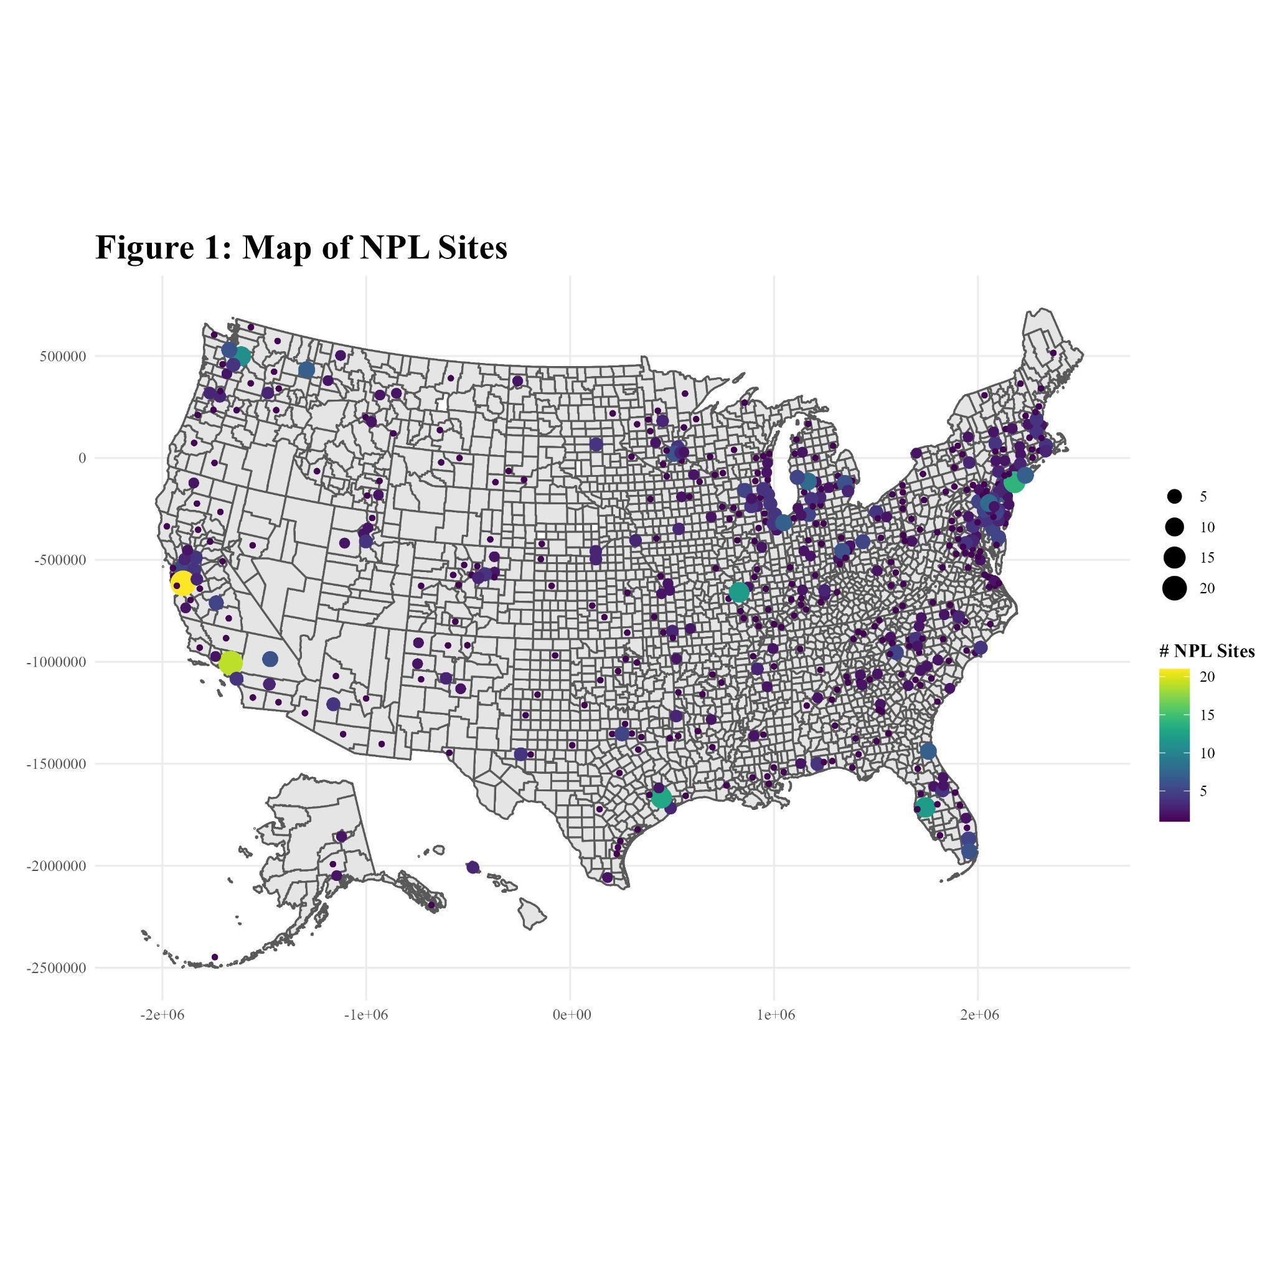.

*Independent Variables*

The main predictor in this analysis is proximity to EPA Superfund National Priorities List Sites. This is a program established by the Comprehensive Environmental Response, Compensation, and Liability Act of 1980 (CERCLA), generally referred to as the EPA "Superfund". This is a novel measure as of yet in political science as far as I can tell, but I would argue that it is more appropriate here than the commonly used measures (generally the levels of one or more specific pollutants in the air or water) for two reasons. First, measures of any given pollutant are hardly a holistic measure of the entire local system. Knowing the levels of ozone in an area might be helpful in certain questions, but on their own their use in this study would not give us a good picture of the conditions that respondents live with. Secondly, I doubt that the average respondent keeps track of pollutant levels on a frequent enough basis to impact their political behavior. The NPL list solves both of these issues. By measuring proximity to a source of environmental degradation, we can more clearly connect the issue with a respondents daily life and, more importantly, Superfund sites are extremely visible as can be explained best through a narrative of the process each site (ideally) will go through. The life cycle of an EPA NPL listed site begins when a community realizes that there has been some event which has caused the area to be degraded, usually through pollution by some contaminant. The site is brought to the attention of the EPA and is given a Preliminary Assessment inspection, where an employee of the EPA surveys the site and determines if the report is viable for continued investigation. Then, a more detailed assessment leads to a review process during which a site is approved if it meets one or more of the following requirements:

* A score of 28.50 or higher on the Hazard Ranking System (HRS)
* EPA determination that the site is a significant threat to public health
* EPA determination that remediation (an authority limited to NPL sites) will be more cost-effective than emergency removal (a more accessible tactic)
* Top Priority designation by a State or Territory government
* Recommendation by the Agency for Toxic Substances and Disease Registry (a sister agency also established by the CERCLA/Superfund legislation)

The key part of this process to its viability as a variable in this analysis is community recognition of the site. Since their recognition of the site is necessary for it to be noticed by the EPA, and due to the visibility of established sites (see Appendix 1), we can assume that most respondents would recognize that they live near or directly in a contaminated area[2].

The measure for NPL proximity is measured in two ways. I utilize the lowest level of geocoding available for ANES respondents, legislative districts, to narrow down their location. I take the geographic center points of each district and calculate the distance to all NPL sites in the corresponding state[3]. The measure *proximity* is the mean distance for that respondent, which has been logged to account for skewness. Second, *In District* is a simple dichotomous variable indicating if there are any sites in that legislative district. Finally, I include a control for the average HRS score for all sites within the state in order to account for the impact that site severity might have on perceptions of pollution in the area.

I also include additional respondent-level demographic predictors from the ANES which might influence survey sampling. *Age* is a 7 level-factor ranging from “18-24” to “65+”; *female* is a dichotomous measure of gender with female as the reference category; and *race* is a 3 level nominal factor with the levels "Asian American", "Black or African American”, and "Hispanic or Latino". Finally, I include a control for which census region the respondent lives in, under the assumption that the context of racial identity varies across region meaning that states, say, in the South are not comparable to those in the West, Midwest, or Northeast. Descriptive statistics for all of the variables in the model can be found in Appendix 3.

In practical terms, I can see two plausible pathways for this relationship, which I will term the low visibility model and the high visibility model. Under the low visibility model the community in question does not recognize when the local environment has been degraded and as such their levels of linked fate are not impacted. However, some actor (such as the state government, an individual who does not broadcast their actions to the larger community, etc.) contacts the EPA and begins the decision process to name the contamination zone an EPA superfund site. Once that process concludes the site will either be approved or denied. If the site is denied in the low visibility model, I expect no change in reported levels of linked fate. The people living near the site did not notice the instigating degradation event and a denied site does not receive the visibility boost that an approved one has, so they would continue to live their lives as usual. In the counterfactual in which the same site was approved by the EPA and thus received the accompanying signage, fences, and other visible indicators that some pollutant exists in the area, I expect linked fate would increase. Respondents who were previously unaware of the site would not necessarily see site approval as a relief from concerns brought to the government, because they were not aware that a problem existed in the first place. However, community members who are naive to the impact of environmental degradation in their local area who suddenly come upon an EPA superfund site would likely be shocked and have cause to contemplate how and why the degradation happened in the first place. Thus, the only way for linked fate to go is up.

**Figure 2: Theoretical Pathways**

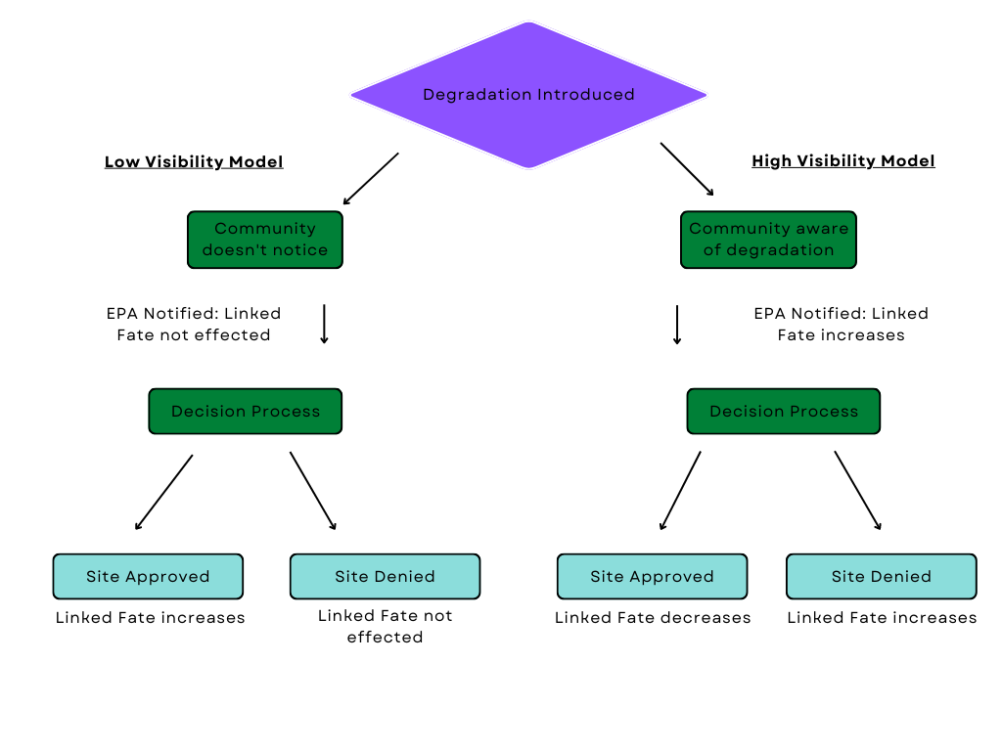

Under the high visibility model, I expect that an approved site will lower levels of linked fate for a similar reason. A community who has brought concerns about local environmental degradation to the federal government and then sees action from the EPA, in the form of site approval, has had their concerns addressed. Linked fate is in many ways an expression of the way a respondent sees the way they are treated by the government. If the government is responsive, linked fate should decrease. Finally, a denied superfund site should increase linked fate. A community has expressed distress about environmental degradation and has been ignored, which would likely drive perceptions of adverse treatment by the government. The data currently available for this analysis include only approved sites, so this analysis will look only at (1) if change in proximity to approved sites over time impacts at all, and (2) which direction that change is in [4].

**Method**

This analysis relies on a Bayesian Multilevel model with uninformative priors and an explicit nesting structure which places respondents within legislative districts within states. I estimate the model via the probabilistic programming language Stan (relying on the CmdStanR interface, a lightweight alternative to brms) which implements the No-U-Turn sampler variant of Hamiltonian Markov Chain Monte Carlo (Carpenter et al. 2017; Hoffman and Gelman 2014). My dependent variable is a factor, so I run a version of a multinomial model which is parameterized in this syntax as a categorical likelihood with a multivariate logit link function. The nesting structure specified above (respondent within district within state) is introduced in the model as a random intercept for district and a random state intercept with a random time slope that varies across states but not across districts. I apply a QR decomposition to the predictor matrix for each category, which reduces multicollinearity in the predictors and allows for more computational and statistical efficiency in the sampling. The priors in this model specify 15 degrees of freedom, a mean 0, and a scale of 1, which reflects a high level of uncertainty about the baseline relative probabilities, allowing for outliers but constraining the bulk of the prior into a realistic range.

I run six Markov chains in parallel for 5,000 iterations each. The first 3,000 iterations for each chain are discarded after the initial warm-up adaptation stage leaving us with 12,000 posterior samples for subsequent analysis[5]. Posterior predictive checks (Appendix 2: Figure 3) indicate that this model predicts a distribution that is very close to that of the sample data (Gelman et al.2004; Gelman & Hill, 2007).

**Results**

In interpreting these results, we come upon the issue of integrating out the random effects in the model. This is important to do because

The results of this analysis indicate that change in proximity to EPA superfund locations over time does impact levels of linked fate. Figure 4 shows the change in probability for each of the potential outcomes when jointly manipulating both Time and Proximity; more plainly, the change in probability of each response if every respondent increased 1 unit in Proximity between 2016 and 2020. Recall, Proximity is modeled as the logged mean distance to all superfund sites in a given state. As we can see in Figure 4, as the Proximity term increases respondents are less likely to respond “Not a lot” to the linked fate question and more likely to respond “A lot”. So, as respondents get farther away on average from cleanup sites their level of linked fate **Chart, line chart
**increases.

**Conclusion**

This analysis attempts to bridge the bodies of literature surrounding climate politics and minority political behavior. I argue that because structural inequality is so tightly linked to the impacts of environmental degradation, environmental degradation should have an impact on the political behavior of racially and ethnically marginalized groups. As environmental degradation makes climate politics a more impactful facet of human life, perceptions of group positionality and systemic environmental inequality will incentivize marginalized groups in affected areas to identify more strongly with their ethnic or racial identity and thus report a higher level of linked fate. Just as social identity influences environmental attitudes, so too should climate change influence identity and group consciousness. I find that over time, respondents who live closer to EPA superfund cleanup sites have lower levels of linked fate, indicating that government aid in mitigating the impacts of environmental racism are likely to positively impact the way that minority groups view their relationship with the government and broader society.

This research is limited in a few ways. Most notably, the measure that I use for proximity to EPA superfund sites is flawed in that the ANES does not geocode their responses. As such, the closest estimate that I am able to use for the locations of each respondent relies on their legislative district. While center points of legislative districts allows for some variation in the proximity measure, ideally, I would be using the exact location, or something closer to city or county level geocoding. Secondly, this time series only utilizes 2 waves of the ANES. I would prefer to have a longer time series, however the linked fate question on the ANES has only been asked two times. The only alternative large scale political survey which might be a better alternative is the Collaborative Multiracial Post-Election Survey. While the CMPS is infinitely preferable to the ANES in terms of sample size (the CMPS oversamples Black, Asian, and Hispanic respondents and thus has an N 3x the size of the ANES for the linked fate question, which is only asked to those groups), the linked fate question changed significantly between the 2016 and 2020 waves, and as such is not comparable. So, for now, the two waves of the ANES is the better option of the two.

Despite these limitations, these results are promising for scholars of climate politics and of racial and ethnic dynamics in the United States. The analysis is evidence that while marginalization and climate politics are intertwined, efforts on behalf of the government can mitigate the adverse effects of human centered changes to local ecosystems.

**References**

Aihounton, Ghislain, and Arne Henningsen. 2021. "Units of measurement and the inverse hyperbolic sine

transformation." The Econometrics Journal 24:(2): 334-351.

Anderson, C., Anderson, K, Door, N., DeNeve, N., & Flanagan, M. 2000. Temperature and aggression. ‖ In M. Zanna

(Ed.). *Advances in experimental social psychology*. New York: Academic Press

Ara Begum, R., R. Lempert, E. Ali, T.A. Benjaminsen, T. Bernauer, W. Cramer, X. Cui, K. Mach, G. Nagy, N.C.

Stenseth, R. Sukumar, and P. Wester, 2022: Point of Departure and Key Concepts. 2022. *In: Climate Change*

*2022: Impacts, Adaptation, and Vulnerability. Contribution of Working Group II to the Sixth Assessment Report of the*

*Intergovernmental Panel on Climate Change* [H.-O. Pörtner, D.C. Roberts, M. Tignor, E.S. Poloczanska, K.

Mintenbeck, A. Alegría, M. Craig, S. Langsdorf, S. Löschke, V. Möller, A. Okem, B. Rama (eds.)]. Cambridge

University Press. In Press.

Bromley-Trujillo, Rebecca, Mirya R Holman. 2020. Climate Change Policymaking in the States: A View at 2020,

*Publius: The Journal of Federalism*, 50(3): 446–472. https://doi.org/10.1093/publius /pjaa008

Butz, Adam M., and Jason E. Kehrberg. 2016. “Estimating anti-immigrant sentiment for the American states using

multi-level modeling and post-stratification, 2004–2008.” Research & Politics

3 (2). https://doi.org/10.1177/2053168016645830.

Carpenter, Bob, Andrew Gelman, Matthew D. Hoffman, Daniel Lee, Ben Goodrich, Michael Betancourt, Marcus

Brubaker, Jiqiang Guo, Peter Li, and Allen Riddell. 2017. “Stan: A Probabilistic Programming Language.” Journal of

Statistical Software 76 (1). https://doi.org/10.18637/jss.v076.i01.

Caughey, Devin, and Christopher Warshaw. 2019. “Public Opinion in Subnational Politics.” Journal of Politics 81 (1):

352–363.

Dawson, M.C., 1994. *Behind the mule*. Princeton University Press.

Fielding, Kelly S., and Matthew J. Hornsey. 2016. "A social identity analysis of climate change and

environmental attitudes and behaviors: Insights and opportunities." Frontiers in psychology 7: 121.

Fearon, J.D., 2006. Ethnic mobilization and ethnic violence. *The Oxford handbook of political economy*, pp.852-868.

Egan, P. J., & Mullin, M. (2017). Climate change: US public opinion. *Annual Review of Political Science*, 20, 209-227.

Gelman, Andrew, John B. Carlin, Hal S. Stern, and Donald B. Rubin. 1995. *Bayesian data analysis*. Chapman and Hall/CRC.

Gelman, Andrew, and Jennifer Hill. 2007. Data Analysis Using Regression and Multilevel/Hierarchical

Models. New York: Cambridge University Press.

Gomez, B., Hansford, T., & Krause, G. 2007. ―The Republicans should pray for rain: weather, turnout, and voting in

U.S. Presidential elections.‖ *The Journal of Politics*, 69, 649-663.

Hazlett, Chad, and Matto Mildenberger. 2019. "Wildfire exposure increases pro-climate political behaviors." Available at SSRN 3452958.

Hoffman, Matthew D., and Andrew Gelman. 2014. “The No-U-Turn Sampler: Adaptively Setting Path Lengths in

Hamiltonian Monte Carlo.” Journal of Machine Learning Research 15 (1): 1593–1623.

https://doi.org/10.5555/2627435.2638586.

Jamal, A. 2005. The political participation and engagement of Muslim Americans: Mosque involvement

and group consciousness. *American Politics Research*, 33(4), 521-544.

Junn, J., 2007. FROM COOLIE TO MODEL MINORITY: US Immigration Policy and the Construction of

Racial Identity1. *Du Bois review: Social science research on race*, *4*(2), pp.355-373.

Junn, Jane and Natalie Masuoka. 2008. “Asian American Identity: Shared Racial Status and Political Context.”

*Perspectives on Politics*, 6:4: 729-740.

Lax, Jeffrey R., and Justin H. Phillips. 2009a. “Gay Rights in the States: Public Opinion and Policy

Responsiveness.” American Political Science Review 103 (3): 367–386.

2009b. “How Should We Estimate Public Opinion in The States?” American Journal of

Political Science 53 (1): 107–121. https://doi.org/10.1111/j.1540-5907.2008.00360.x.

Leighley, J. E. (2001), *Strength in Numbers: The Political Mobilization of Ethnic and Racial Minorities*, Princeton:

Princeton University Press.

Mackay, Caroline ML, Michael T. Schmitt, Annika E. Lutz, and Jonathan Mendel. 2021. "Recent

developments in the social identity approach to the psychology of climate change." *Current Opinion in*

*Psychology* 42: 95-101.

McLeman, R. 2018. Thresholds in climate migration. *Population and environment,* 39(4), 319-338.

Michael, R. & Zumpe, D. 1983. Annual rhythms in human violence and sexual aggression in the United States and

the role of temperature. *Social Biology*, 30,263-278

Muro, Mark, David G. Victor, and Jacob Whiton. 2022. “How the Geography of Climate Damage Could Make the

Politics Less Polarizing.” *Brookings*. https://www.brookings.edu/research/how-the-geography-of-climate

-damage-could-make-the-politics-less-polarizing/ (April 13, 2022).

Nagel, Joane, 1997. *American Indian Ethnic Renewal: Red Power and Resurgence of Identity and Culture*. Oxford

University Press.

Nagel, J. 2012. Intersecting identities and global climate change. *Identities*, 19(4), 467-476.

Nixon, R., 2013. *Slow Violence and the Environmentalism of the Poor*. Cambridge, MA: Harvard University Press.

O'Connell, Heather A. 2012. The impact of slavery on racial inequality in poverty in the contemporary US South.

*Social Forces* 90, 3 : 713-734.

Palamarek, Daniel L., and Brendan Gail Rule. 1979. "The effects of ambient temperature and insult on the motivation to retaliate or escape." *Motivation and Emotion* 3. 1: 83-92.

Park, David K., Andrew Gelman, and Joseph Bafumi. 2004. “Bayesian Multilevel Estimation with

Poststratification: State-Level Estimates from National Polls.” Political Analysis 12 (4).

Pigeon, N. and Fischoff, B., 2011. The role of social and decision sciences in communicating uncertain climate risks.

*Nature Climate Change*, 1, 35–41.

Piguet, Etienne, Antoine Pécoud, and Paul De Guchteneire. 2011. "Migration and climate change: An overview."

*Refugee Survey Quarterly* 30. 3: 1-23.

Roston, E., 2008. *The carbon age: how life’s care element has become civilization’s greatest threat.* New York, NY:

Walker Publishing Company.

Sanchez, Gabriel R., and Natalie Masuoka. 2010. "Brown-utility heuristic? The presence and contributing

factors of Latino linked fate." *Hispanic Journal of Behavioral Sciences* 32, no. 4: 519-531.

Soyapi, C., and Kotzé, L.J., 2016. Environmental Racism, Slow Violence and the Extractive Industry in Post-apartheid

South Africa: Marikana in Context. *Verfassung und Recht in Übersee [online]*, 49, 393–415. Available from:

https://doi.org/10.5771/0506-7286-2016-4-393 [Accessed 8 June 2020].

Spisak, B.R., State, B., van de Leemput, I., Scheffer, M. and Liu, Y., 2022. Large-scale decrease in the social salience of climate change during the COVID-19 pandemic. *Plos one,* 17(1), p.e0256082.

Stock, P., 2007. Katrina and anarchy: a content analysis of a new disaster myth. *Sociological Spectrum,* 27, 705–726.

Stout, Christopher T., Kelsy Kretschmer, and Leah Ruppanner. 2017. "Gender linked fate, race/ethnicity,

and the marriage gap in American politics." *Political Research Quarterly* 70, no. 3: 509-522.

Tierney, K., Bevc, C., and Kuligowski, E., 2006. Metaphors matter: disaster myths, media frames, and their

consequences in hurricane Katrina. *The Annals of the American Academy of Political and Social Science,* 604,

57–81.

Tomaskovic-Devey, Donald, and Vincent J. Roscigno. 1997. "Uneven development and local inequality in the US

South: The role of outside investment, landed elites, and racial dynamics." In *Sociological forum*, 12,.4: 565-597.

Kluwer Academic Publishers-Plenum Publishers.

Tausanovitch, Chris, and Christopher Warshaw. 2014. “Representation in Municipal Government.” American Political

Science Review 108 (3): 605–641.

Tyson, Alek, Brian Kennedy, and Cary Funk. 2021. “Gen Z, Millennials Stand out for Climate Change Activism, Social

Media Engagement with Issue.” *Pew Research Center Science & Society.* https://www.pewresearch.org/science

/2021/05/26/gen-z-millennials-stand-out-for-climate-change-activism-social-media-engagement-with-issue/ (April 21,

2022).

US Census Bureau. 2022. “The Chance That Two People Chosen at Random Are of Different Race or Ethnicity

Groups Has Increased since 2010.” https://www.census.gov/library/stories/2021/08/2020-united-states-population

-more-racially-ethnically-diverse-than-2010.html (April 21, 2022).

Verba, Sidney et al. 1999. “Race, Ethnicity and Political Resources: Participation in the United States.

*British Journal of Political Science*. 23:453-497.

Vermeersch, P., 2012. Theories of ethnic mobilization: overview and recent trends. *Elgar Handbook of Civil War and*

*Fragile States.*

World Bank. “Social Dimensions of Climate Change.” *World Bank*. https://www.worldbank.org/en/topic/social-

dimensions-of-climate-change#1.

**Appendix 1: Epa Site Signage**

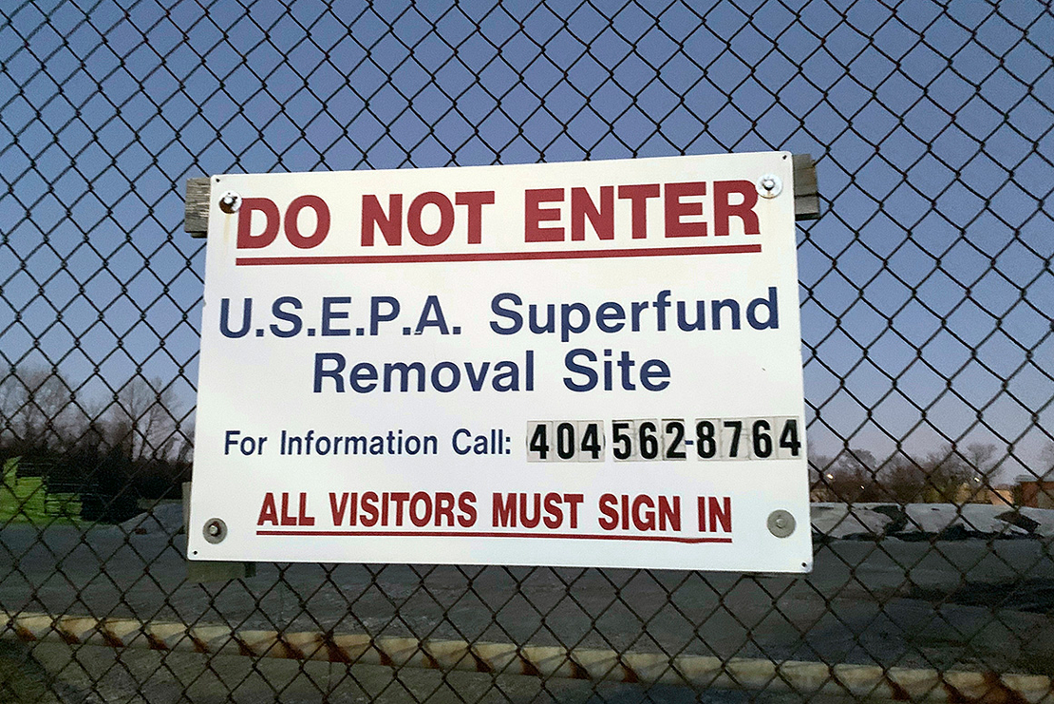

Photo Credit: Kimberly Chandler, E&E NEWS

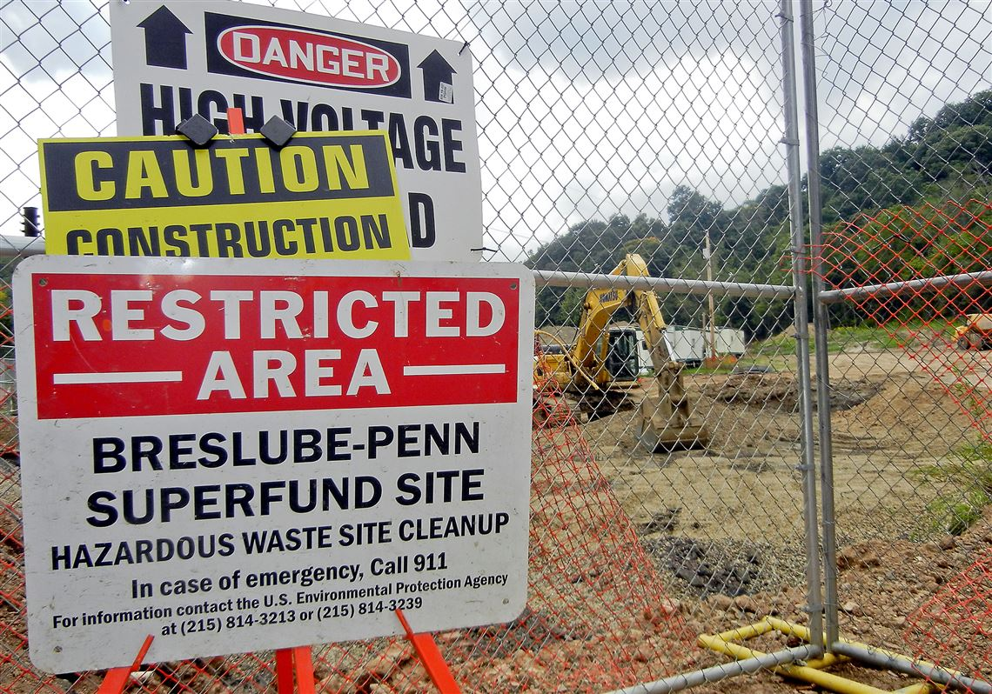

Photo Credit: Len Barcousky, Post-Gazette

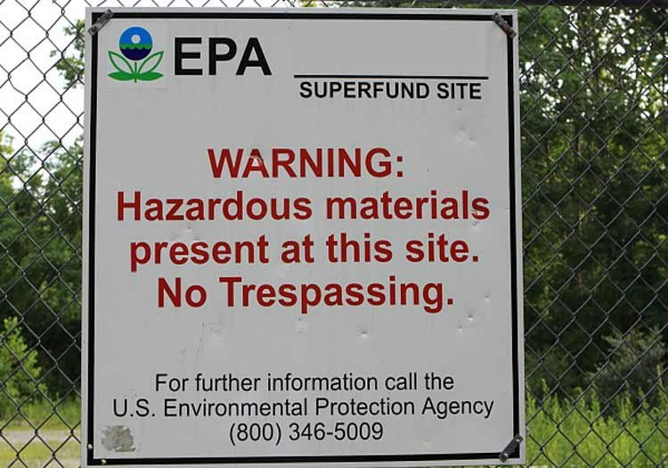

Photo Credit: US Environmental Protections Agency

**Appendix 2: Posterior Predictive Check**

**Appendix 3: Descriptive Statistics**

# Summary Statistics

|  |  |  |  |  |  |  |  |
| --- | --- | --- | --- | --- | --- | --- | --- |
| **Variable** | **N** | **Mean** | **Std. Dev.** | **Min** | **Pctl. 25** | **Pctl. 75** | **Max** |
| Proximity (log(Km)) | 2282 | 238.489 | 131.385 | 14.776 | 140.944 | 335.457 | 887.68 |
| In District | 2293 | 0.624 | 0.485 | 0 | 0 | 1 | 1 |
| Average HRS Score | 2293 | 43.848 | 2.446 | 36.555 | 41.551 | 45.817 | 56.94 |

|  |  |  |
| --- | --- | --- |
| **Variable** | **N** | **Percent** |
| Race | 2293 |  |
| ... Black | 951 | 41.5% |
| ... Asian or Pacific Islander | 329 | 14.3% |
| ... Hispanic | 1013 | 44.2% |
| Sex | 2283 |  |
| ... Male | 1024 | 44.9% |
| ... Female | 1259 | 55.1% |
| Education Level | 2268 |  |
| ... High School or Less | 639 | 28.2% |
| ... Some College | 823 | 36.3% |
| ... Bachelor's Degree or Higher | 806 | 35.5% |
| Age | 2222 |  |
| ... 18-24 | 215 | 9.7% |
| ... 25-29 | 225 | 10.1% |
| ... 30-34 | 232 | 10.4% |
| ... 35-44 | 465 | 20.9% |
| ... 45-54 | 388 | 17.5% |
| ... 55-64 | 357 | 16.1% |
| ... 65+ | 340 | 15.3% |
| Party | 2283 |  |
| ... Strong Democrat | 840 | 36.8% |
| ... Democrat | 399 | 17.5% |
| ... Independent-Democrat | 283 | 12.4% |
| ... Independent | 331 | 14.5% |
| ... Independent-Republican | 144 | 6.3% |
| ... Republican | 137 | 6% |
| ... Strong Republican | 149 | 6.5% |

1. I use the phrase “climate politics” to refer not only to the political discourse surrounding climate change itself, but also to the broader, more general conversations which includes but is not limited to discussions of pollution and other types of environmental degradation, natural resources, green energy, environmental racism, etc.
2. While I argue that this measure is the most appropriate available, I do recognize that it does have its faults. Primarily in the possible selection bias inherent to the NPL decision process, which could plausibly be connected to racial issues as well. In future iterations I hope to expand the variable to include both funded and non funded sites as well as a control for EPA intervention. Government intervention could mitigate the effect of polluted environments on linked fate.
3. Centroids and proximity are calculated via the sf package in R (Pebesma et al 2022).
4. Data for sites denied superfund status is currently being cleaned and will be utilized in future iterations of this project.
5. Estimation is performed under R version 4.2.1 using the brms package (Bürkner 2017, 2018; R Core Team 2021), which serves as a front-end for regression models using Stan’s implementation of Hamiltonian Markov Chain MonteCarlo.